Five Ways Challenge Pack
Introduction:

Public Health and LiveWell Dorset are inviting the county to join a wellbeing
challenge to take care of our health and wellbeing at this difficult time.

Based on the Five Ways to Wellbeing, the Five Ways Challenge will guide
participants through five steps to greater self-care. Participants will exercise the ways to wellbeing by connecting with others virtually; taking notice of the present moment, maintaining daily physical activity, learning new skills and giving to others.

Working together we are inviting your employees to join the challenge; to strengthen and support those who are home-working, home-schooling and adjusting to the ‘new-norm’.

Let’s reach out together, and help you stay connected with your employees.

#WorkingApartTogether

This pack contains two copy and paste blog/intranet/email posts and social media copy to share the challenge with your employees.
What next?
When your employees join the Five Ways Challenge, we'll send them information, inspiration and tips to take care of their wellbeing at this time.

Intranet/Blog posts:
These articles can be easily shared; simply copy and paste into:
- an article you can post to your Intranet
- an email that you are sending out to employees to stay in touch
- your business blog
Intranet/Blog Post 1:
Join LiveWell Dorset’s Five Ways Challenge to boost your wellbeing
Taking care of our wellbeing at this time is more challenging than ever, yet also more important than ever. As we all adopt to this new way of life, it’s imperative we look after ourselves and our workforce.
Your employees may be tired, burdened with isolation, apprehensive and anxious about the weeks to come. Some may have been furloughed, or their hours reduced, and there may be strains at home that make everyday life a constant struggle.
We can help you help them, by joining together virtually. We are taking steps to restoring our wellbeing together. Let us share with you a five-step plan to recover the morale of your employees and strengthen everyone’s wellbeing. We’re in this for the long-haul – it’s a marathon, not sprint.
We’re training to become endurance athletes at wellbeing and self-care. Join us?
Are you getting your five-a-day?
What if I said your workforce could come out of this feeling stronger, happier and more connected than ever? It is possible. Introducing, the Five Ways Challenge: the five-step plan to take care of wellbeing.

The Five Ways to Wellbeing provide the essential framework to self-care. By ticking off the five ways, day-by-day, little-by-little, we can all become elite wellbeing athletes and champions of our own self-care. By connecting to others, taking notice of the good stuff, maintaining physical activity, learning new things and giving to others; we’ll exercise the ways to wellbeing.

We know we need our five-a-day dose of fruit and veg… the same is true of the five ways: we need our daily dose of wellbeing. By getting our five-ways-of-wellbeing-a-day, we will prevail. We will endure. This is the five-step plan to bring wellbeing to the fore.
Can do
Your mission, should you choose to accept it, is to join our virtual five-ways training programme and share it with your business, your colleagues, your team, your employees. We’ll bring the coaching, training plan; information and inspiration. All you need is a mindset of belief and determination to follow the plan.
It’s time we switched our focus away from what we can’t do, and on to what we can do. Seize the day. Join the Five Ways Challenge to supercharge everyone’s wellbeing.
Join. [Link to www.livewelldorset.co.uk/five-ways-challenge/
---
Intranet/Blog Post/Article 2:
Working from home: Five tips for you and your family

Start your day right!
For you:
Although no-one is flying out the door at the crack of dawn, the day still has to have a start, middle and end. Fix your schedule according to the new-norm; when are you at your most productive? What do you need to achieve before the working day starts? What sets you up for the day?

For your family:
If your children are of school age, try to encourage them to start their day with purpose - like making their bed – then they too are achieving things before they tackle the academics. Without the need to get up, breakfasted and out the door on time could equal the temptation to switch to the school holiday lie in routine.
If your children are of pre-school age it’s fair to say that mornings are likely to be early starts all round. If you are used to going out to work, make a 15-minute appointment with yourself to check in with YOU, note how you are feeling.
If you are employing the television as a babysitter for these precious 15 minutes, forgive yourself!

Get moving at home!
For you & for your family:
Mr. Wicks is the new Head of Physical Education in our house; tune in to The Body Coach YouTube channel every morning at 8:55am for the 9am PE lesson with Joe Wicks to get EVERYONE active. If you thought this work out was just for children, think again – it’s exhausting! It’s a great up and at ‘em motivator, so give it a go.

Forgive yourself & the children – often
For you:
No one was prepared for this; if you are working from home and you are finding it hard to be productive take some time out to plan your day. Be realistic. A single productive hour is far more rewarding than multi-tasking and achieving nothing for three.
If you have the facilities, set up a daily team talk and connect with small groups within your business – it will do wonders for morale and help everyone maintain a sense of belonging. Even if you have been furloughed, it’s worth maintaining those relationships. Connection is everything!
For your family:
You are not expected to be a Headteacher with twenty years’ experience under your belt! You are most likely a working parent and something somewhere has got to give. All practical life lessons are as good as academics. Remember, everyone’s mental wellbeing is of paramount importance. We can always catch-up on learning; what’s important right now is a sense of peace, safety, security and love within your four walls.

4. Get out of the house
Current Government Guidelines state that we only take one form of exercise a day, for example a run, walk, or cycle - alone or with members of your household.
In line with these new rules, we would recommend -
For you:
Being outdoors, especially whilst we are all home-bound, promotes wellbeing. Prescribe yourself some time to be outside of the house. Even if this is just to stand with your face to the sun on your doorstep or walking up and down the garden path.
If your one form of daily exercise is taken in solitude, it’s no bad thing either. Mindful walking, or running is a great way to clear your mind. If ever there was a time to discover podcasts, it’s now. Or get Olympian Michael Johnson, comedian Sarah Millican to coach to run 5km using this app! Finding something to tune in to, so you can zone out whilst walking is of huge psychological benefit.
For your family:
Whilst we are all restricted to one form of physical exercise out of doors per day, we need to make it count. When the sun is out, but it’s still chilly, try and get a walk in during the warmer hours of the day so that everyone can soak up some Vitamin D and stride it out comfortably. Taking that break from home and work will increase productivity for the afternoon and lift everyone’s spirits!

Plan breaks for the children, and yourself
For you & your family:
The children aren’t expected to work flat out and neither are you. When you need a burst of productivity, or you have to join that video call in peace; give the children a well-earned break. Take the breaks you need too – it’s important to know when to stop, and just as you would have breaks from your desk at work you must also do so at home.

…One last thing for us all
It’s ok to be finding this new world daunting and overwhelming. You’ve probably noticed a marked increase in communications from work, friends and family. Social media is awash with the latest theories, life-hacks, and sensationalist stories.
- Step away as much as you need to – and only used trusted sources to stay informed
- Safeguard news-free time for your household in the evenings, you’ll find it helps promotes a better night’s sleep
---
LinkedIn posts
- copy and paste the text provided
- use the ‘Five Ways’ graphic we have supplied to accompany the text
This will ensure continuity of the message you send, and clear signposting to the challenge webpage where your employees can find further information and join the Five Ways Challenge.
---
Are you taking care of your wellbeing? We’ve joined forces with LiveWell Dorset to support our employees’ self-care. We invites you to join the Five Ways Challenge: the five-step plan to take care of wellbeing, an essential framework to promote self-care. It’s simple to do, day-by-day, and will flex those wellbeing muscles that so often get neglected.
Share your #FiveWaysStory via our social media channels and with your team!
Join here [www.livewelldorset.co.uk/five-ways-challenge]
----
Workforce Wellbeing is something we are taking very seriously during this difficult time. It’s our mission to help you come out of this feeling stronger, happier and more connected than ever. Is it possible? We believe it is, and thanks to LiveWell Dorset we there are Five Ways daily to do so.
The Five Ways Challenge is a five-step plan to take care of wellbeing, helping you connect, stay active, learn, give to others and take notice of the good stuff.
Share your #FiveWaysStory via our social media channels and with your team!
Join here [www.livewelldorset.co.uk/five-ways-challenge]
-----
Calling all home-workers! How are you coping during this new and challenging time? Are you juggling family life, home schooling and establishing a new pattern of working from home?
We’re here to offer support where we can, and find ways together to look after your wellbeing. For some top tips, take a look at our articles on LiveWell Dorset
[https://www.livewelldorset.co.uk/articles/]

Tweets
- copy and paste the ready-made Tweets direct to your Twitter feed for easy sharing and quick signposting to LiveWell for your employees
- use the ‘Five Ways’ graphic we have supplied to accompany the text
Taking care of your wellbeing is more important than ever. Join the
#FiveWaysChallenge to plan your self-care. livewelldorset.co.uk/five-ways-
challenge/

Supercharge your wellbeing: Join the #FiveWaysChallenge
livewelldorset.co.uk/five-ways-challenge/

Join @LWDorset’s #FiveWaysChallenge to take care of your wellbeing
livewelldorset.co.uk/five-ways-challenge/

Are you getting your five-a-day? livewelldorset.co.uk/five-ways-challenge/
#FiveWaysChallenge

Train to become an endurance athlete in wellbeing and self-care:
livewelldorset.co.uk/five-ways-challenge/ #FiveWaysChallenge

Connect with others; take notice of the present moment, maintain daily physical activity, learn new skills and give to others. Join the #FiveWaysChallenge livewelldorset.co.uk/five-ways-challenge/

Graphics:
- Use these to accompany any of the content we have provided you with. The visual cue will help your audience associate the message with LiveWell and our wellbeing plan. Also attached to your email as .jpg files:
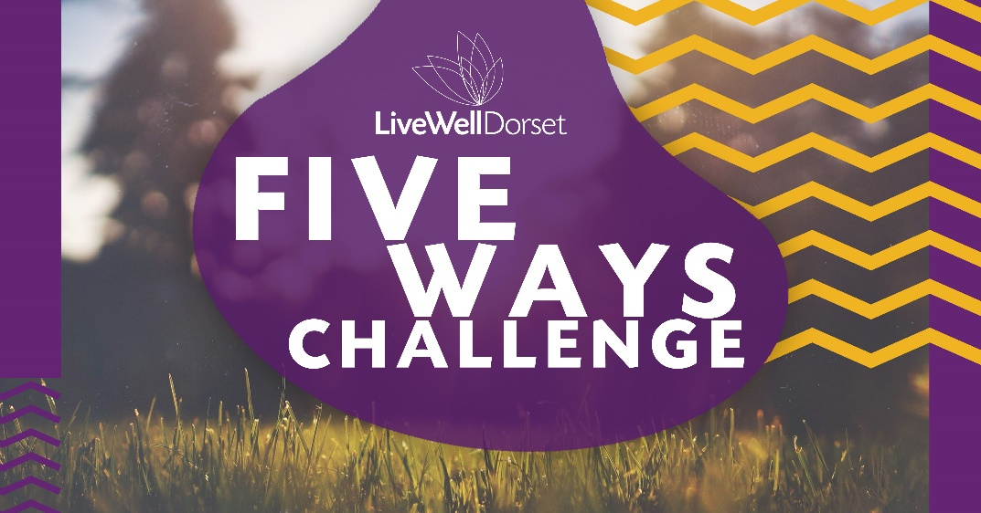
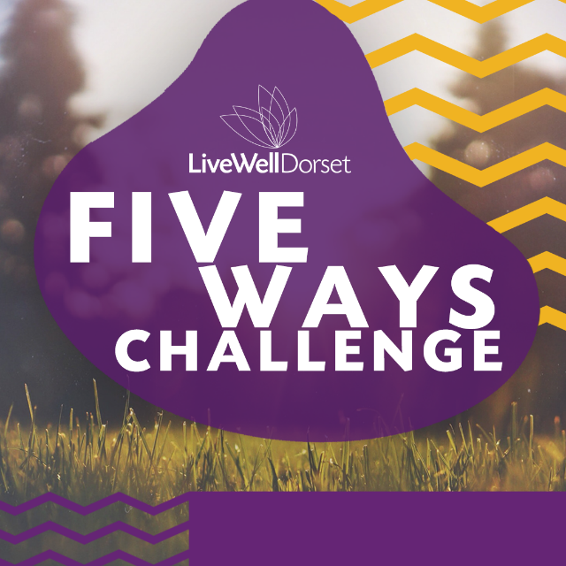
Contacts:
Julia Calleja
LiveWell Dorset Development Lead
Julia.calleja@livewelldorset.co.uk
07442 660 248

Polly Durrant
LiveWell Dorset Business Development Coordinator
polly.durrant@livewelldorset.co.uk
07388 377 184

